By M.G.Mauney
Meet Chance, Rescued by a Special Human---Who Became a Special Rescue Dog!
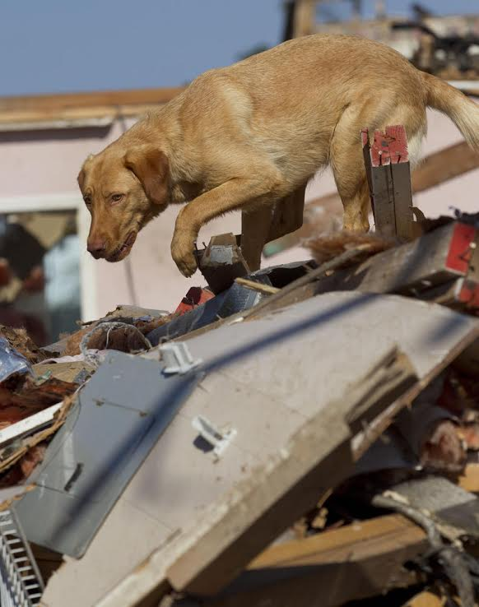
A so-called “throw-away” dog, Chance the lab mix began as a puppy in a high-kill shelter. He thought he’d found salvation with a family that took him home, but the family swiftly returned him for daring to chew on things, as puppies will. A foster home scooped him up, and Trace Sargeant, owner of STAR K-9 Talent and Wrangling Agency adopted him. She gave him his name as she said he was given a second “Chance” in life. Since then, he has become one of the best search and rescue dogs she’s had in 20 years. It was Chance who was the search and rescue dog flown to Aruba this year to help find new evidence in the Natalie Holloway case.
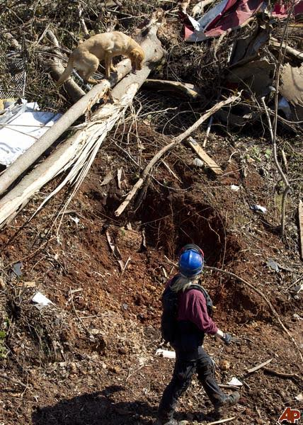
Chance has a long list of adventures and accomplishments. He was called to Tuscaloosa after the devastating hurricane. He found a missing person there in the wreckage, even though the human crew had searched in the debris for five days. He was called to Macon to help solve a murder case. He searched and found someone who had disappeared in metro Atlanta and been featured on the “Disappeared” TV show. He’s even used his fantastic sniffer to confirm an historical Revolutionary War battlefield site from over 235 years ago! And that’s just a few highlights from his prodigious career. No wonder he’s been interviewed on CNN as well as been in several films and TV shows.
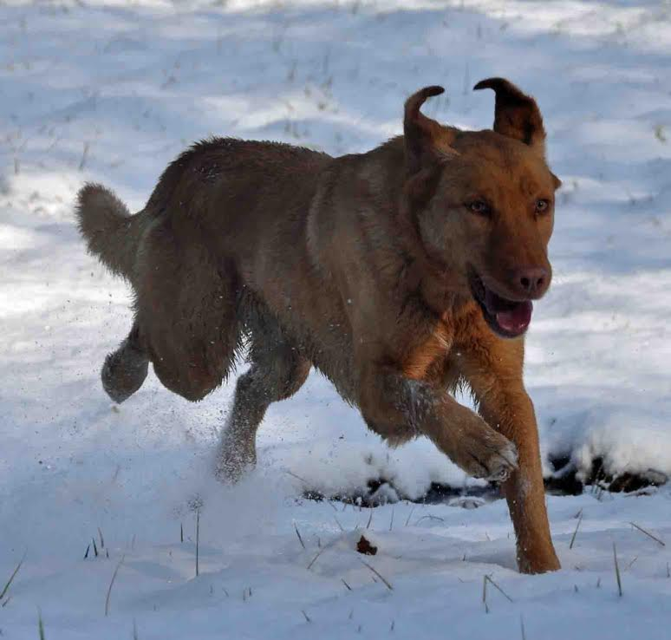

His Golden Retriever/Chocolate Lab heritage has blessed him not only with agility and intelligence, but also an exuberance for life, be it work or play. “He has incredible focus and gives his all,” says Trace, “He doesn’t do anything halfway.”
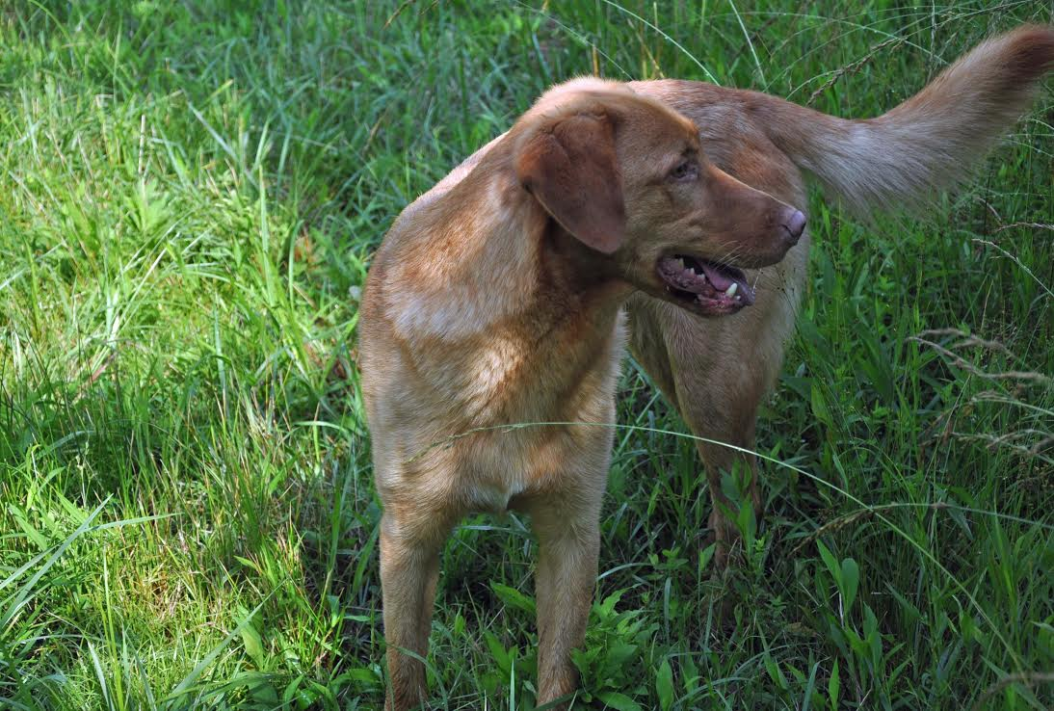
Don’t miss the chance to see Ambassadorable Chance in an actual demonstration using his amazing search skills! It all happens at the Mister Migs Denim Dogs Fashion Blast!
