August 2015

http://americanshootingjournal.com/hide-and-seek-heroes-sar-guru-trace-sargent/

Hide And Seek Heroes – SAR Guru Trace Sargent
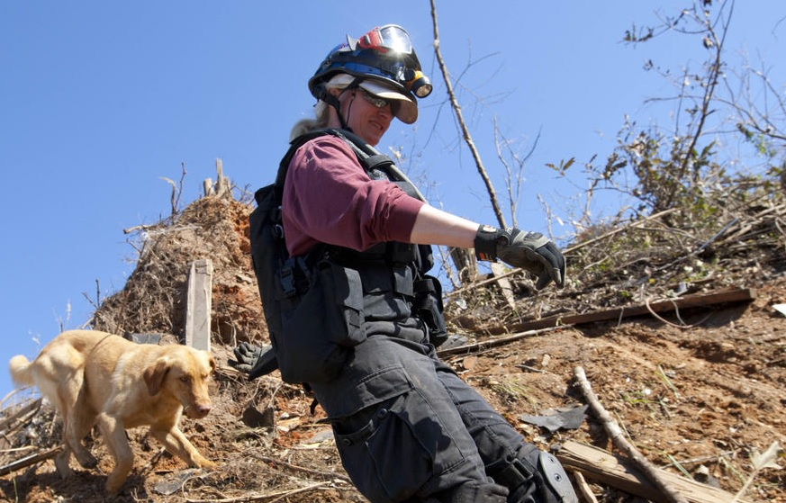

Hide And Seek Heroes Trace Sargent And Her Pack
Story by Tatiana Whitlock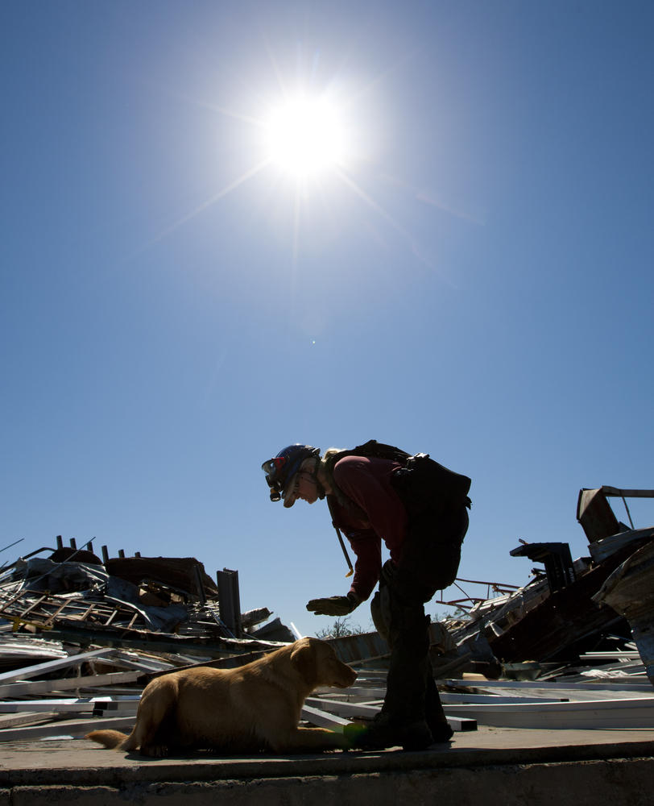
(DAVE MARTIN)
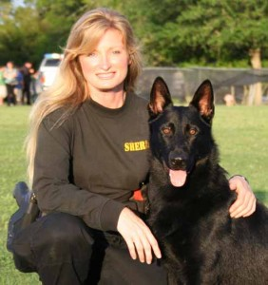
Trace Sargent and Cinco
Looks can be profoundly deceiving. At first glance, Tracy “Trace” Sargent could easily be a high-powered corporate CEO or lead a marketing firm. This petite Georgia blond with a commanding presence and the charisma and intellect to match, looks like she would fit elegantly at the head of a boardroom. You certainly don’t envision this refined, vibrant woman with a sweet Southern drawl to be out enthusiastically hunting lost persons, getting dirty, crawling through rubble, or chasing down fugitives by moonlight. Yet that is exactly what she has been doing with her K9 partners for over 20 years, gracefully shattering stereotypes and saving lives along the way.
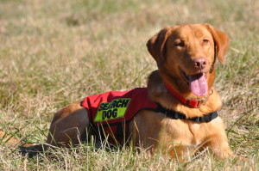
One of Sargent’s pack members Chance
Sargent is one of the nation’s leading K9 handlers who specializes in search, rescue and recovery missions. It’s not something most people want to think about, but there is nothing more precious than a specialized K9 team when loved ones are lost or missing.
One conversation with Sargent and you realize that she is one of those extraordinary people who found her calling, changed her life’s path accordingly and never looked back. A story in Reader’s Digest would depict her as someone who went from not knowing which end of the dog wagged to founding K9 Search and Rescue Specialists, Inc. (K9 SARS) in Georgia. Sargent has also been a program manager for Homeland Security, and has conducted search missions across the globe.
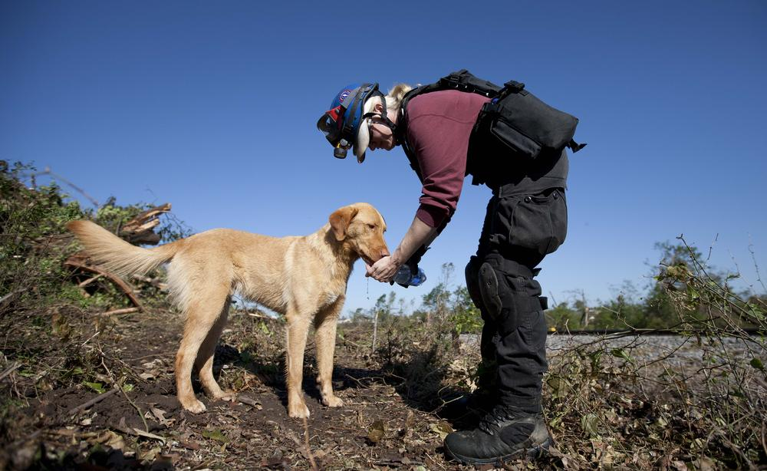
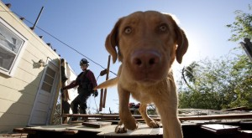The article Sargent credits with starting it all was of a woman and her German shepherd who found a missing three-year-old boy in the woods. The short story resonated with her. “If she could do it, dog gone it, so could I!” recalls Sargent. She could clearly see that having a specialized tool, a K9 partner, to help people in need was her calling in life. The switch was flipped and a dog enthusiast and her pet were transformed into a nationally acclaimed, life-saving K9 team.

“I want to end my life’s sentence with an exclamation point, not a question mark.”
Chance receives national recognition with CNN in 2013.
Sargent’s methods for teaching her dogs, and herself, on how to find a human being would time and again prove successful, but the scope and depth of her knowledge in public safety didn’t stop there. After her initial beginning, Sargent asked herself, “What if I actually found somebody? What am I going to do?” That’s when she became an EMT. Throughout her work, she noticed that most of the crews used specialty radios. “Everyone was using these funny radios,” Sargent notes, so she learned how to use them and became a certified HAM radio operator. As she was working with firefighters, police officers and emergency personnel, she asked, “Ya’ll get paid to have this much fun?” She then became a firefighter, police officer and certified in emergency management. She has also earned several college degrees along the way, and continues her life-long passion for learning, as evidenced by her recent certification as a forensic sketch artist, putting her naturally gifted artistic talents to work in the never-ending battle of good versus evil. Any one of these professions can define a career, but Sargent gracefully embodies them all.

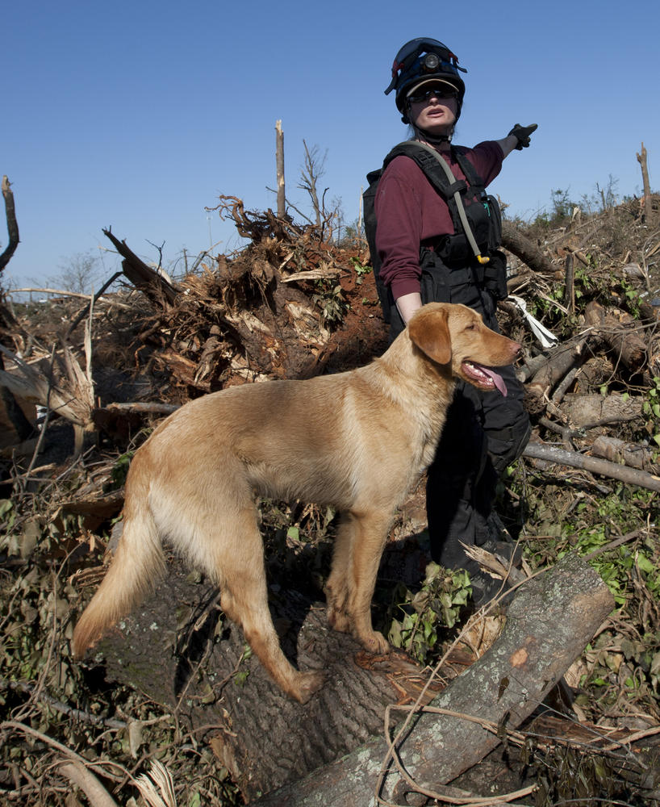
Sargent and her K9 teams have been deployed on numerous highprofile cases, such as the search for Natalee Holloway, the teenager who disappeared in Aruba in 2005; the Casey Anthony case, a mother accused and acquitted of murdering her two-year-old daughter; and the runaway bride case, where Jennifer Wilbanks disappeared four days before her wedding. At any time Sargent can be found searching through the aftermath of natural disasters like Hurricane Katrina and tornadoes like the one that decimated Tuscaloosa, Ala., for survivors or human remains. (DAVE MARTIN)

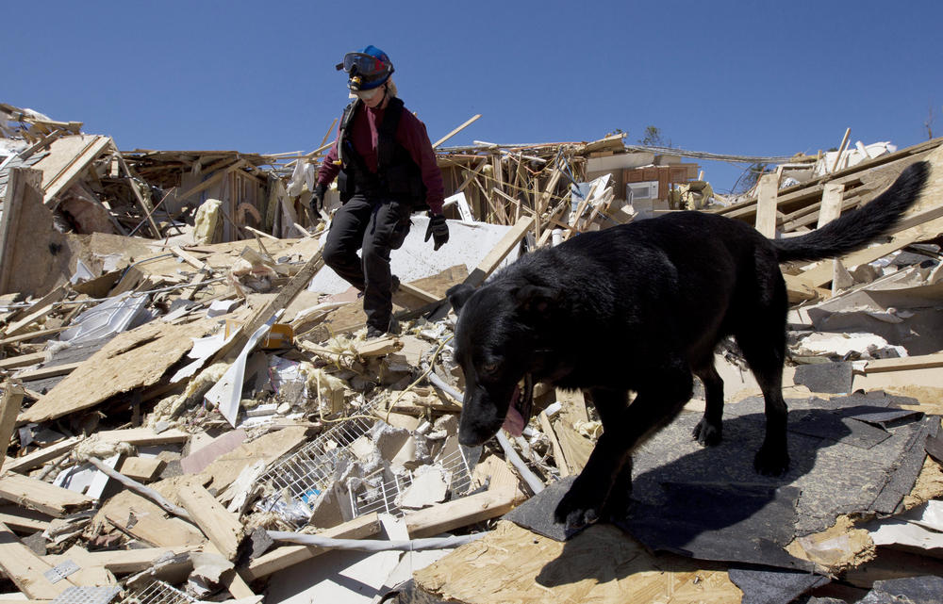
Chance, Cinco and Drako are three of Sargent’s current K9 partners. All are highly trained in search, rescue and recovery, and are some of the most highly decorated dogs in the country. Cinco, a 10-year-old black German shepherd, is perhaps her most talented K9 partner. By the time he was a year old, he had received five national certifications. His predecessor Brooke, a sable German shepherd, was the first dog licensed for SAR work in Georgia, and is honored in the Georgia Animal Hall Of Fame. Together, Sargent and her dogs have found lost children, Alzheimer’s patients and tracked down violent domestic terrorists such as Eric Rudolf, who was known as the Olympic Park Bomber and was responsible for a series of bombings across the South between 1996 and 1998.
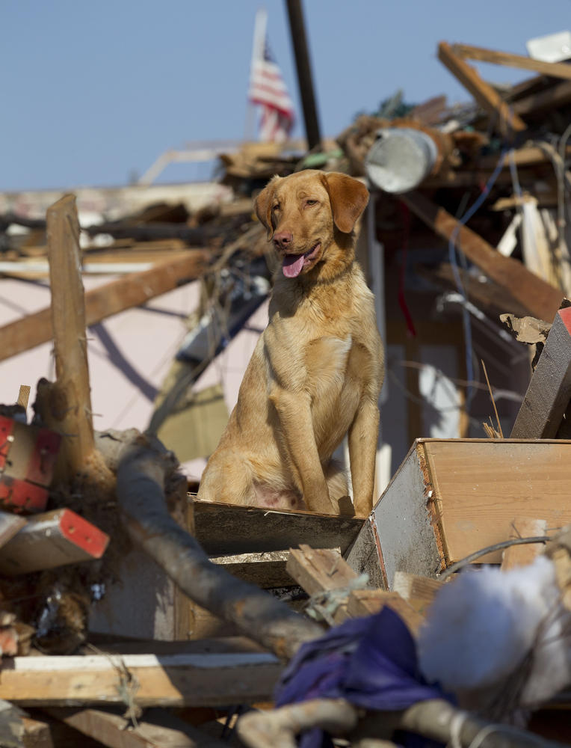
Cadaver dog Chance sits on a pile of rubble during a search for tornado survivors in Tuscaloosa, Ala., Saturday, April 30, 2011. The dogs will sit when they come across the scent of humans. (DAVE MARTIN)
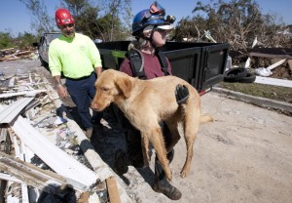The great affection and intense professional relationship between Sargent and her K9 partners is undeniable. While at home they are very much her “kids,” when it is time to get in the truck and respond to a call the dynamic shifts. In the field the mutual respect and professionalism forged through thousands of hours spent working together appears to manifest in an almost telepathic connection. For example, watching Sargent and Chance move through the debris of crushed homes in Tuscaloosa, it is clear the dog’s tuned senses are an extension of Sargent’s instincts, and her ability to translate for her partner enables them to communicate what they find to those who simply don’t speak dog.
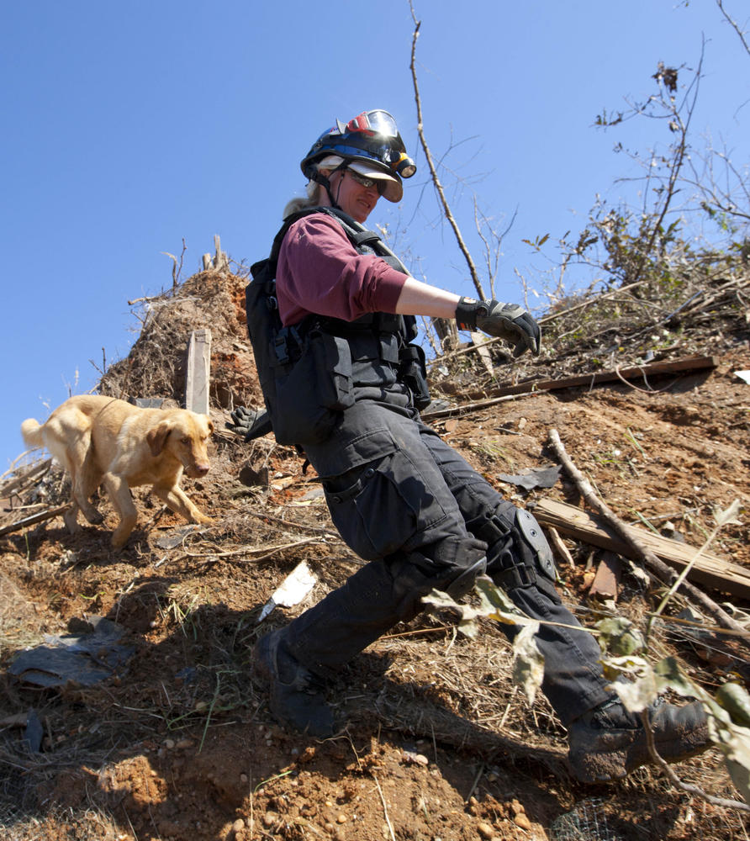
K9 Search and Rescue Specialists Inc., Tracy Sargent works with her cadaver dog Chance as they search a wooded area for survivors in Tuscaloosa, Ala., Wednesday, May 4, 2011. (DAVE MARTIN)
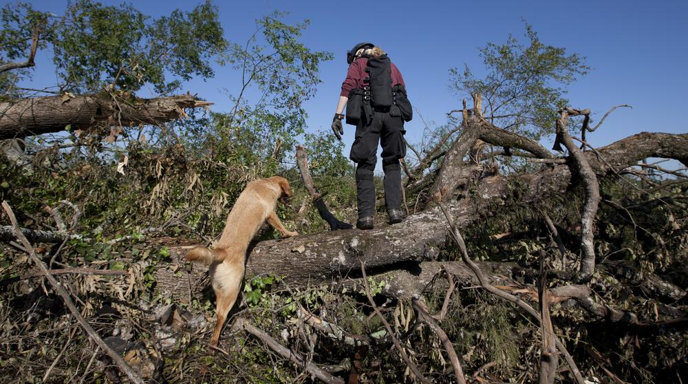
(DAVE MARTIN)
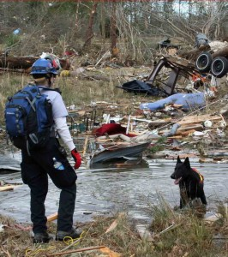
(DAVE MARTIN)
Like Sargent, her K9 teammates can’t be measured by first impressions. You might think that these exquisite breed specimens, with such skill and intelligence must be hand picked from very specific breeders – not the case! “They are all rejects,” says Sargent lovingly. Either a show dog with a cosmetic defect that left him unfit for the championship ring or castoffs in line to be euthanized at the local pound, Sargent’s team is made up of great minds, not pedigrees. She admits, “Not every dog is meant for the kind of work and lifestyle that a SAR dog leads, and shepherds and Labs tend to be more naturally inclined for the job.” It takes a special personality and temperament as much for the dog as for their human to do the work and thrive in a work environment filled with death and destruction.

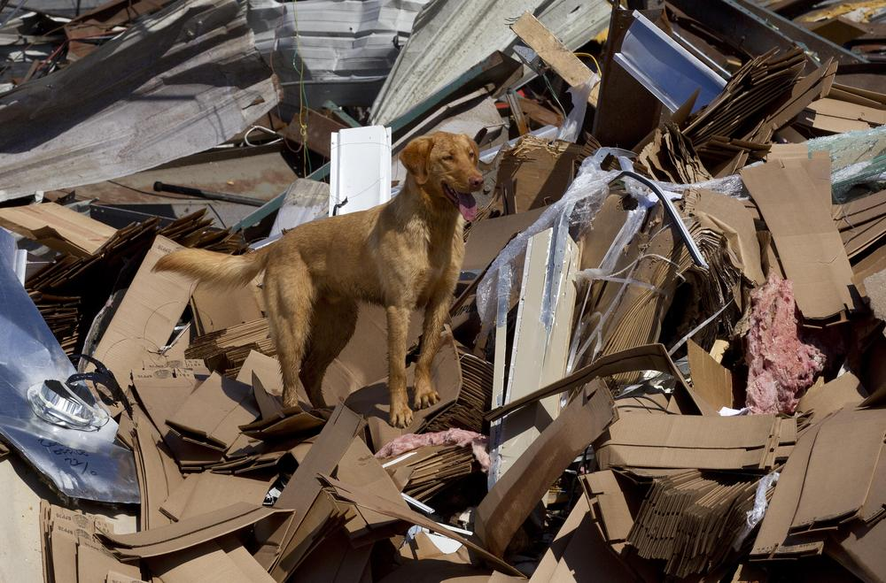
(DAVID MARTIN)
Search and rescue is not without its perils or personal sacrifice. Logan, one of Sargent’s first dogs, was killed in the line of duty. Although that was over 10 years ago, the loss is still one she can’t bring herself to speak about, except to say, “I have learned that it is OK to be afraid. You just can’t let that fear stop you from living.” Sargent even joined the front lines and served overseas in Iraq as a bomb-dog handler, contributing her array of skills in the fight against global terrorism and keeping Americans safe. While some calls result in the joy of finding a missing hiker or child who is still alive, other calls have a grim and emotionally
taxing outcome.
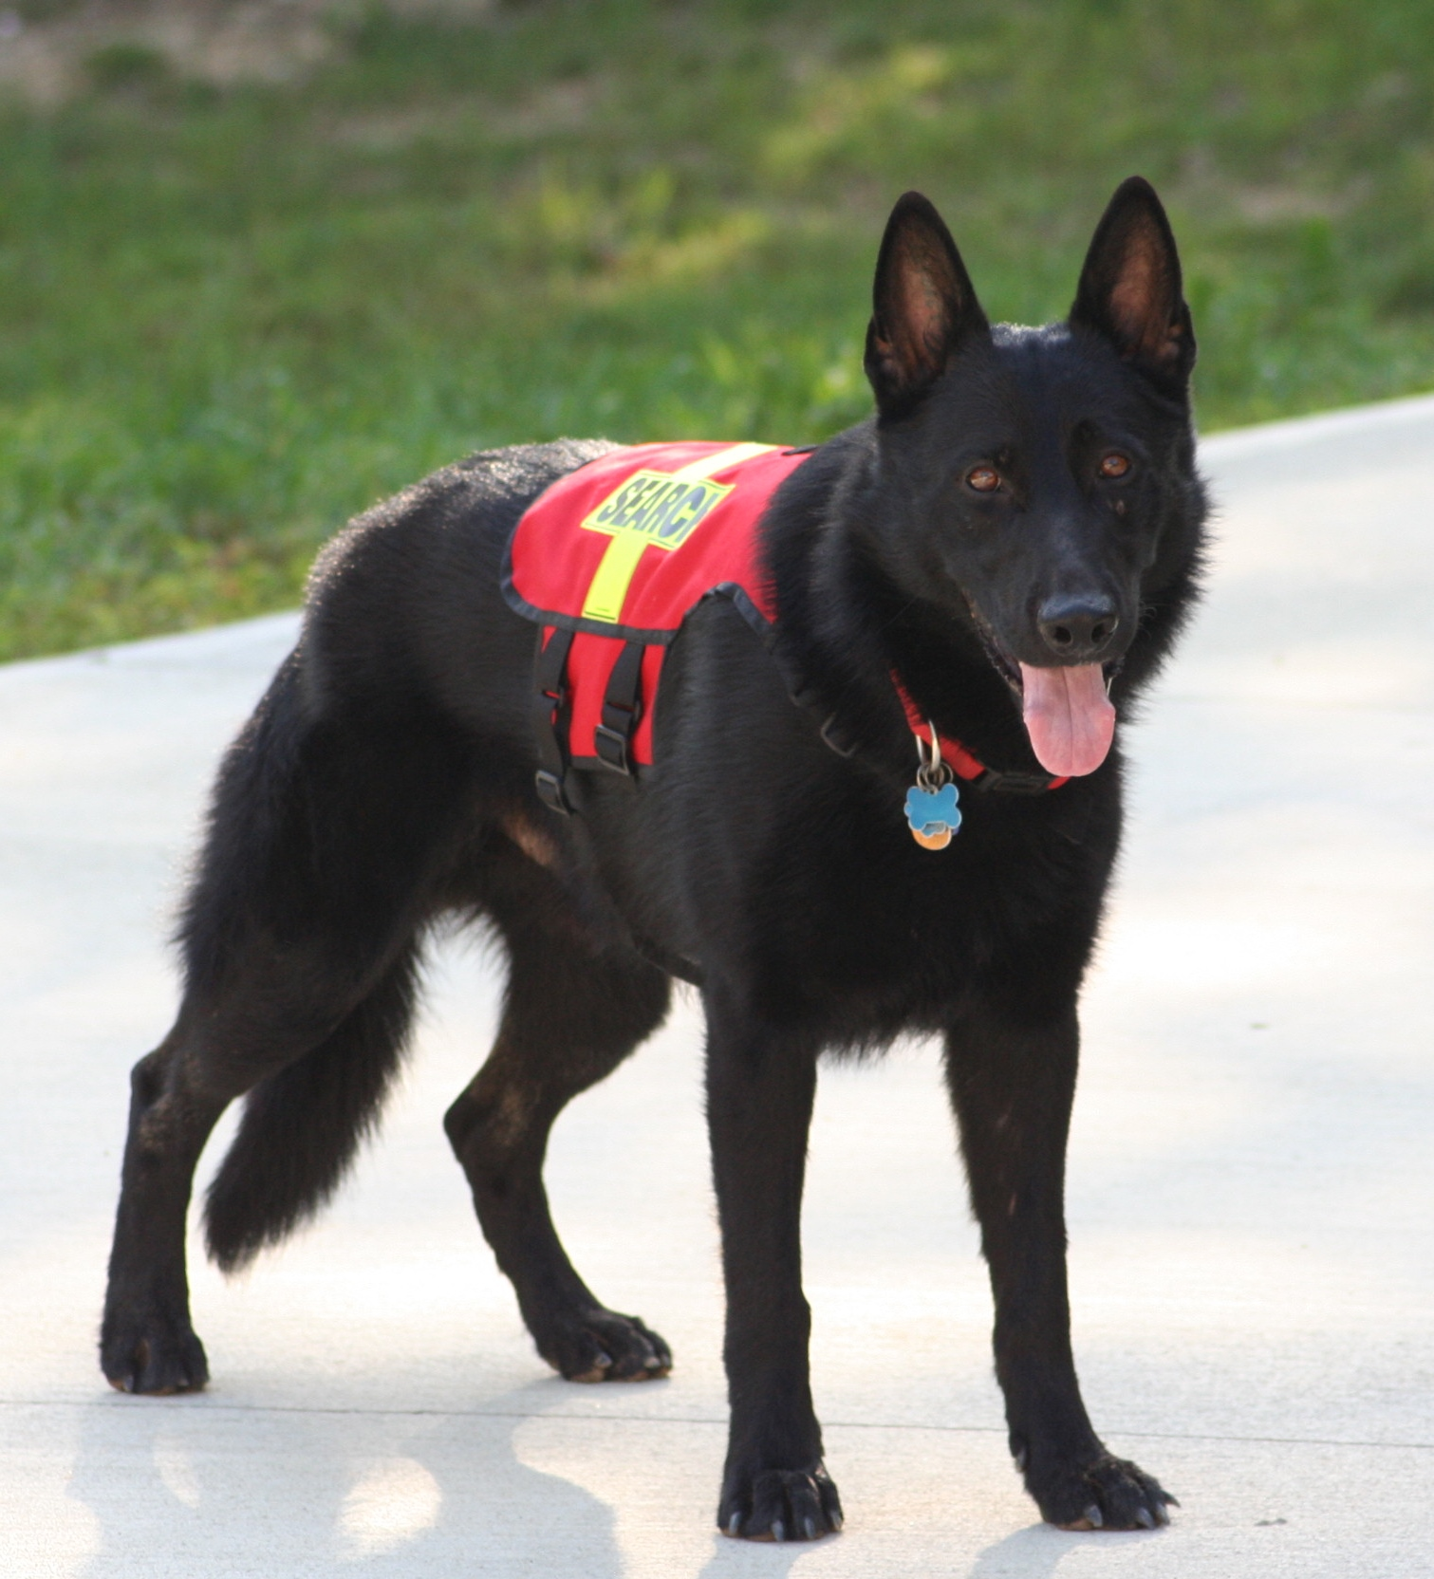
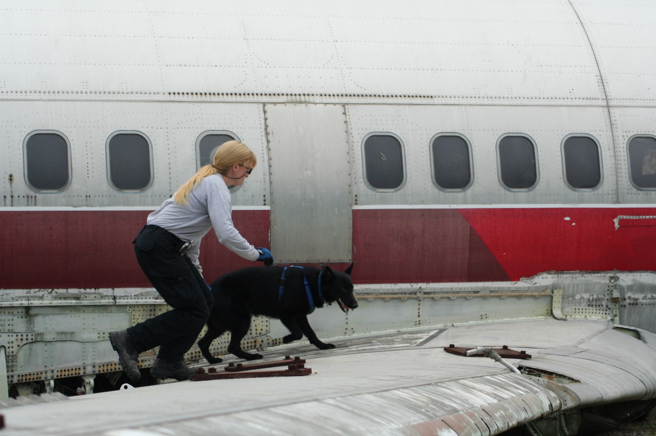
The dogs in Sargent’s team are made up of what she lovingly calls “rejects.” Some were scheduled to be euthanized and were instead saved from the pound, while others were considered cosmetically flawed to be considered as show dogs. (RALPH REICHERT)
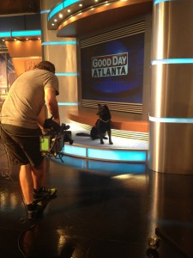
Cinco receives national recognition with Good Day Atlanta in 2013.
On the lighter side, Sargent is a trainer who developed and instructed an award-winning training program for the state of Georgia, has coauthored an internationally published book titled How to train a human-remains detection dog and conducts seminars and workshops for groups seeking this type of specialized training. She finds balance on her farm, which she describes as her sanctuary from the craziness of her life and the world. She also volunteers with her local Humane Society and has plans to launch a new program training dogs to partner with our wounded warriors. Among all of this, she also founded STAR K9, a professional animal talent and wrangling business that trains and casts a Noah’s ark of varying animals and their handlers for the entertainment industry.
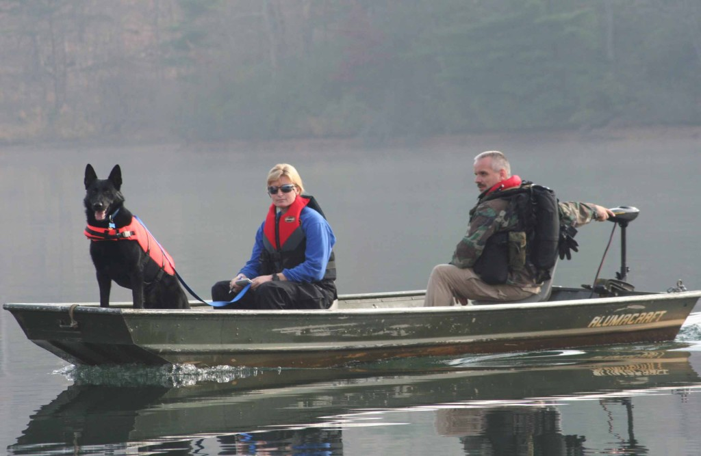
On a lake in Big Canoe, Ga., a fisherman’s boat was found drifting without the owner. There were no signs of the angler because the lake was so large. Sargent and her K9 team were deployed and alerted on a very specific area. The law enforcement divers found the fisherman in that exact spot. He had suffered from a heart attack, fell out of the boat and sadly drowned. Thanks to Sargent and her team, friends and family were able to give him a proper burial. (RALPH REICHERT)

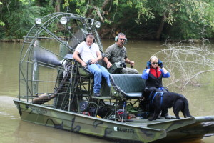
Porterdale Search – September 22 2007 (RALPH REICHERT)
As much media and publicity as there is about Sargent and her extraordinary dogs, she is a quiet and low-key person. Her dogs remain the keystones of all the interesting things that she has done over the years, from Iraq and TV reality shows to international searches and hometown cases. “It’s incredible to think that it all started with one little puppy. I still can’t believe I’ve been everywhere that I’ve been, had the adventures I’ve had and lived to talk about it!” says Sargent. By now Sargent’s family is comfortable with her ever-evolving career, though early on they were skeptical and worried for her safety. Her life is led not by what society expects her to do or be, but by the natural progression of where her life’s passions have led her. She is often asked why she lives her life “outside the box,” and it is an easy question for her to answer.
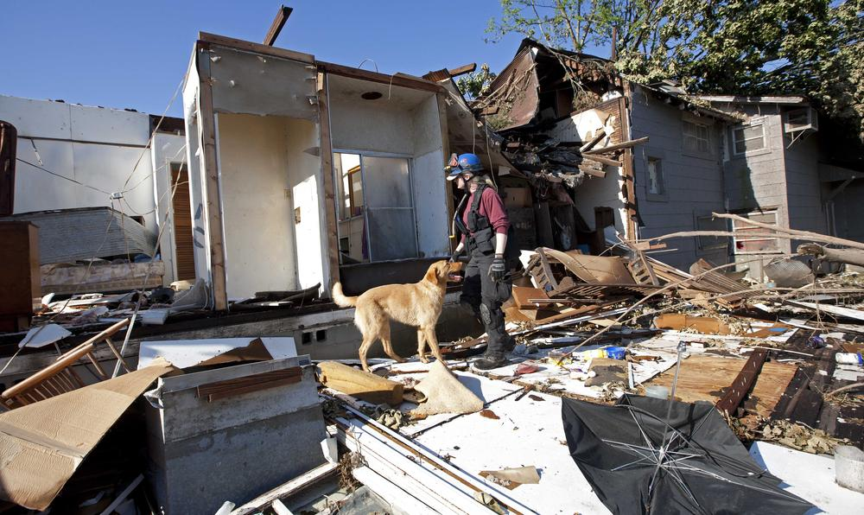
(DAVE MARTIN)
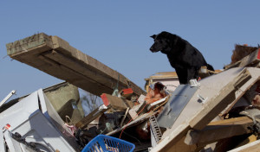
(DAVE MARTIN)
“I want to end my life’s sentence with an exclamation point, not a question mark. I don’t want to have any regrets in my life, and if I should live to be a 100, I don’t want to look back and wonder, ‘What if?’ I’m gong to find those answers while I can, and live my life with passion and purpose,” she says.
It is the dedication and service of first responders like Sargent and her dogs that makes our country a safer and more compassionate place. ASJ
